Lab Task-2

Instructions: Please read carefully
- Please rename this file as only your ID number (e.g. 18-*****-1.doc or 18-*****-1.pdf).
- Submit the file before the deadline in VUES under Lab Task-2. If you cannot complete the full task, do not worry. Just upload what you have completed.
- Initialize TWO integer arrays of different sizes. Merge the input arrays and create a new array. Then print the new array in reverse order.
For example,
Array_1 = {10,20,30,40,50}
Array_2 = {1,2,3,4,5,6,7,8}
Output: 8 7 6 5 4 3 2 1 50 40 30 20 10

Your code here:

#include<iostream>
#include<string.h>

using namespace std;
int main(void)
{
int i;

int a[5];
int b[8];

cout<<"Array_1 : ";
for(i = 0; i < 5; i++)
{
cin>>a[i];
}

cout<<"Array_2 : ";
for(i = 0; i < 8; i++)
{
cin>>b[i];
}
cout<<"Reverse order : ";
for(i = 7; i >= 0; i--)

cout<<b[i]<<" ";

for(i = 4; i >= 0; i--)

cout<<a[i]<<" ";

cout<<endl<<endl;
return 0;
}

Your whole Screenshot here: (Console Output):

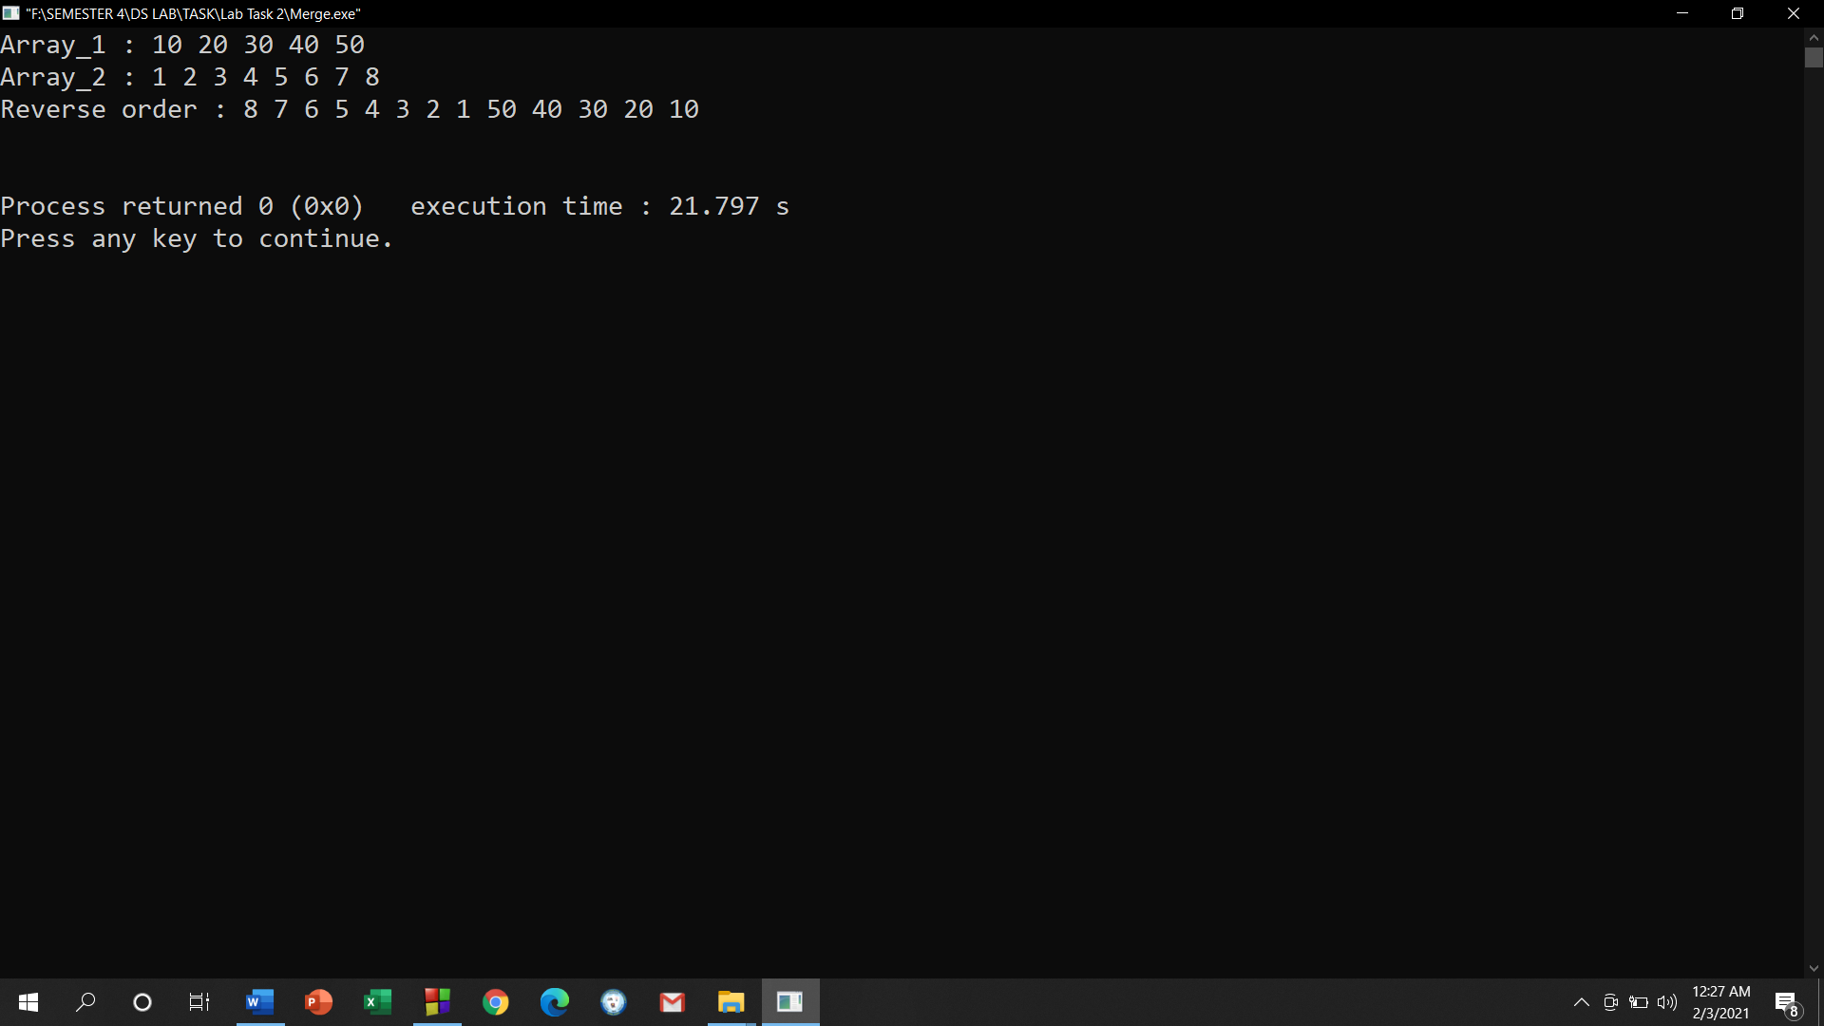

- Initialize TWO integer arrays A and B of different sizes. Make a new array with the common elements between A and B. Print the new array element(s). If there is no common element, output “No common element!”.
For example,
Scenario 1:
Array_1 = {1,4,6,3,6,9}
Array_2 = {5,3,7,1,2,6}
Output: 1 6 3
Scenario 2:
Array_1 = {1,4,6,3,6,9}
Array_2 = {5,8,7,12,21,63}
Output: No common element!

Your code here:
#include<iostream>
using namespace std;
void common_Array(int arry1[], int n1, int arry2[], int n2)
{
int count =0;
for(int a =0; a < n1 ; a++)
for(int b=0; b< n2; b++)
if(arry1[a] == arry2[b])
count++;

if(count == 0){
cout << " No common element!" << endl;
return;
}

int *arry3 = new int[count];
int k=0;
for(int a =0 ; a< n1; a++)
for(int b = 0; b<n2; b++)
if(arry1[a] == arry2[b])
arry3[k++] = arry1[a];

for(int a=0 ; a < count-1; a++)
cout << arry3[a] << " ";
cout<<endl;
}

int main()
{
int n1;
int n2;

cout<<"Enter The number of elements for the 1st Array: ";
cin>>n1;
cout<<"Enter The number of elements for the 2nd Array: ";
cin >> n2;
cout<<endl;

int arry_1[n1];
cout<<"Array_1 : ";
for(int i=0; i<n1; i++)
{cin >> arry_1[i];}

int arry_2[n2];
cout<<"Array_2 : ";
for(int i=0; i<n2; i++)
cin >> arry_2[i];
cout << "\n output : ";
common_Array(arry_1, n1, arry_2, n2);
}
Your whole Screenshot here: (Console Output):
Scenario 1:

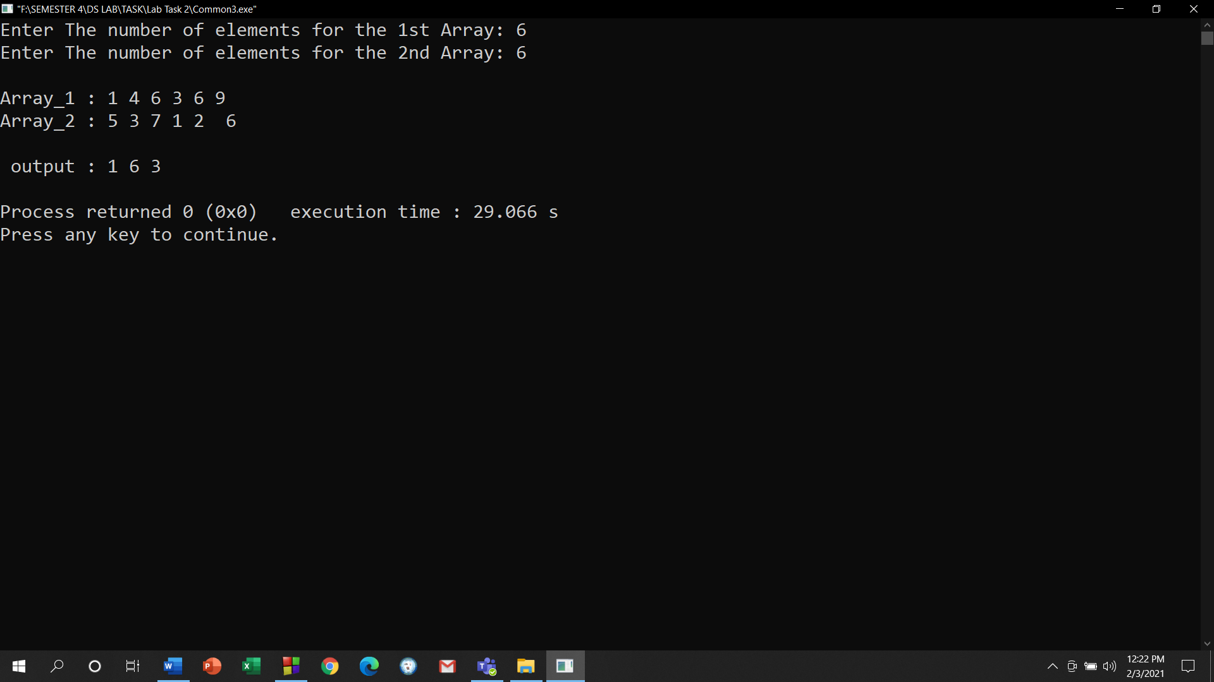

Scenario 2:

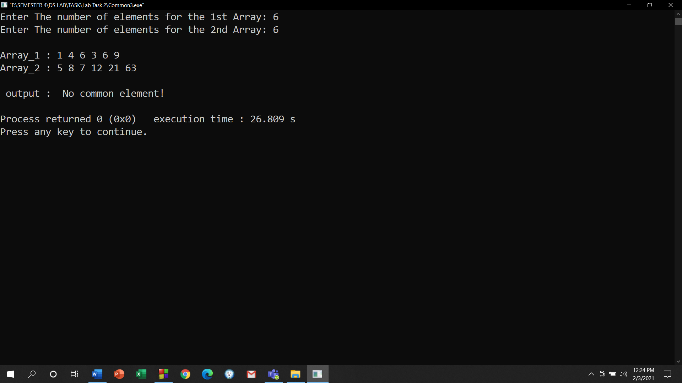

- Initialize an array. Size should be more than FIVE. Write your program to change the array in such a way so that there cannot be any duplicate element in the array anymore. Print the changed array. If the initialized array already had no duplicate elements from the beginning, output a message saying “Array already unique!”;
For example,
Scenario 1:
Array_1 = {1,4,6,3,6,9,1}
Output: 1 4 6 3 9
Scenario 2:
Array_1 = {1,4,5,3,6,9}
Output: Array already unique!

Your code here:

#include<iostream>
using namespace std;

int main()
{
int arr[100], dup[100];
int size, i, j, count,s=0;

cout<<"Enter size of array: ";
cin>>size;

cout<<"Enter elements in array: ";
for(i=0; i<size; i++)
{
cin>>arr[i];

}

for(i=0; i<size; i++)
{
count = 1;
for(j=i+1; j<size; j++)
{

if(arr[i]==arr[j])
{
s++;
count++;

dup[j] = 0;
}
}

if(dup[i] != 0)
{
dup[i] = count;
}
}
cout<<endl;
for(i=0; i<size; i++)
{
if(dup[i] != 0)
{
if(s>0)
cout<<arr[i]<<" ";

}

}

if (s==0)
{
cout<<"Array Already Unique\n";
}

return 0;
}

Your whole Screenshot here: (Console Output):

Scenario 1: 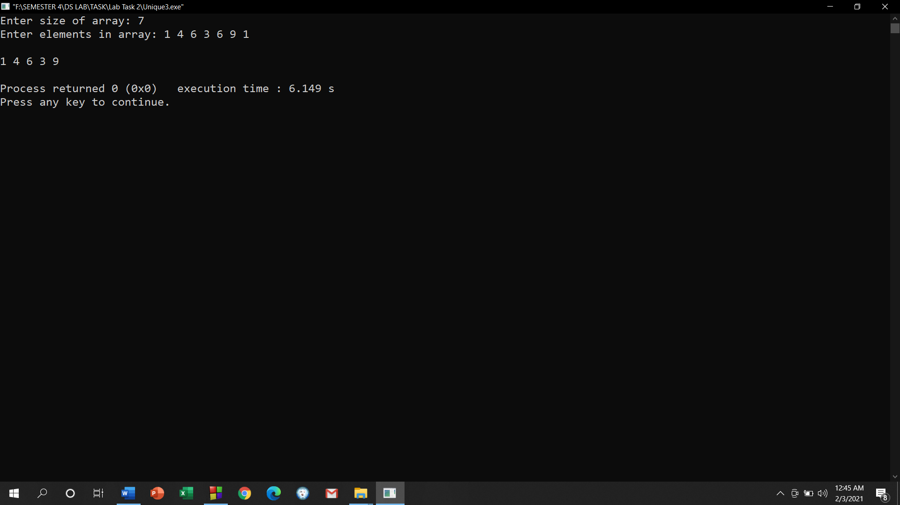

Scenario 2:

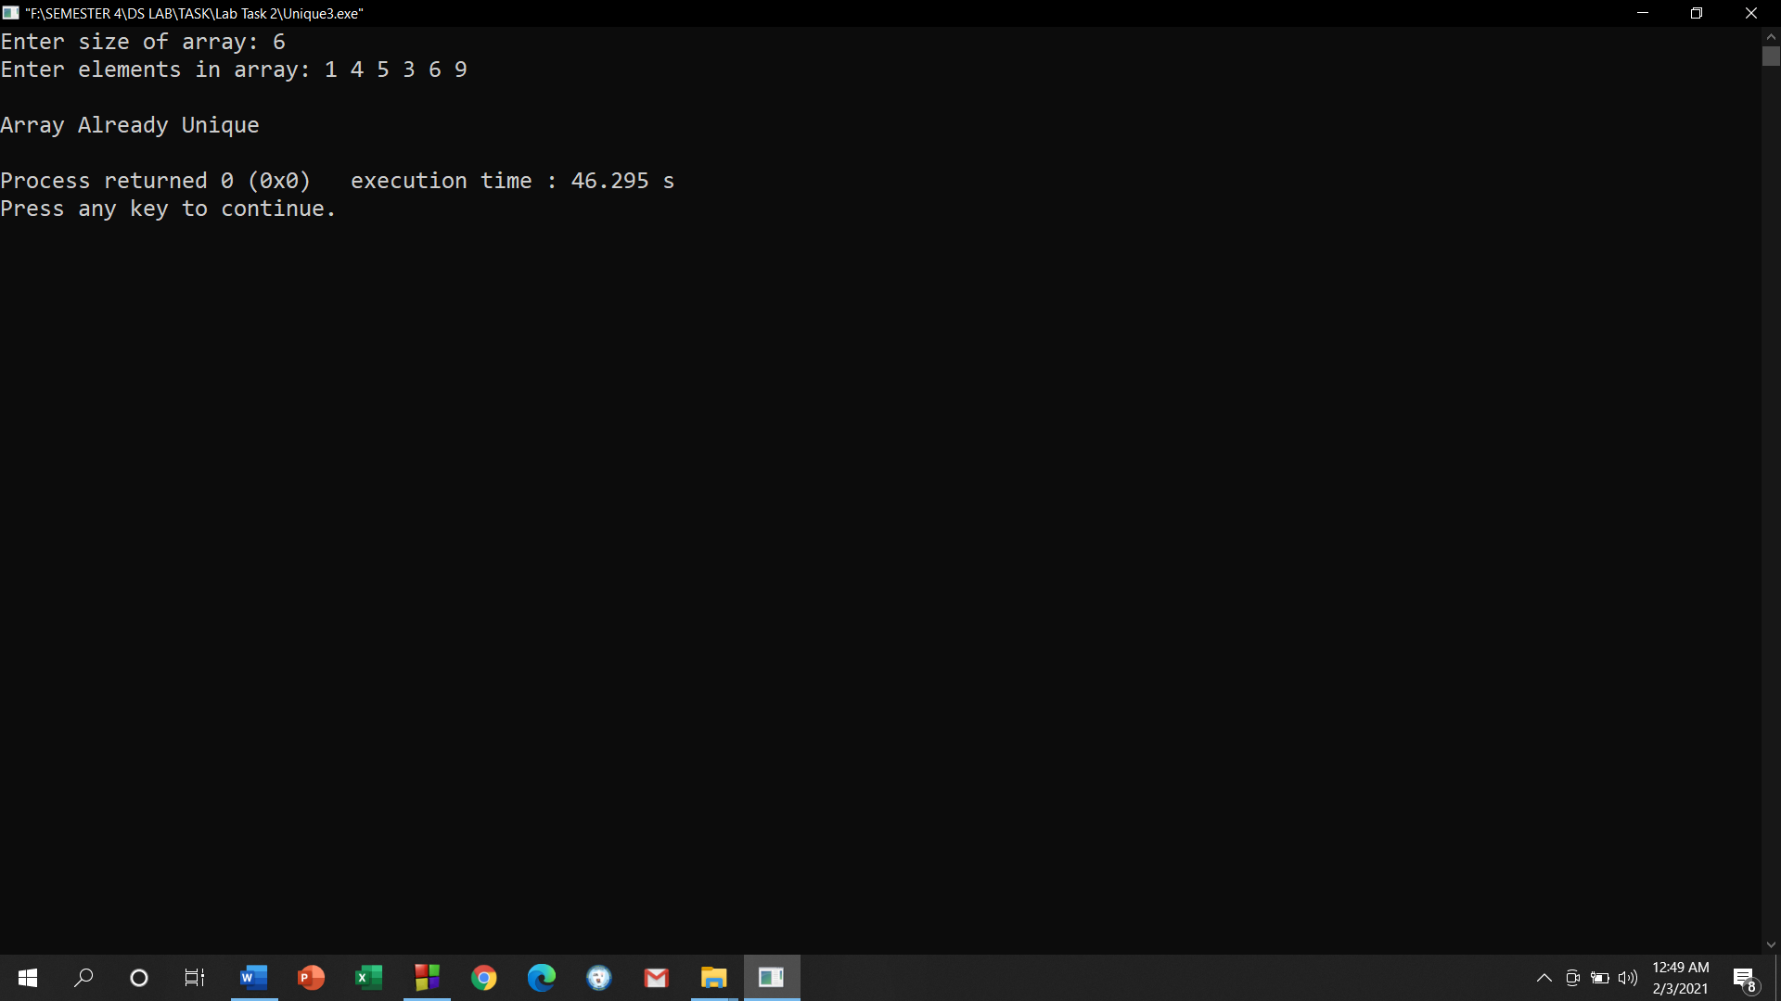

- Initialize an integer array A of size 10. Take an integer as input and print how many times that integer occurs in A.
For example,
Array_1 = {8,4,6,1,6,9,6,1,9,8}
Output:
Input a number to search: 6
The number occurs 3 times in the array

Your code here:
#include<iostream>
using namespace std;

int main()
{
int a[10];
int i;
int n, count=0;

cout<<"Array_1 : ";
for(i = 0; i < 10; i++)
{
cin>>a[i];
}
cout<< " Input a number to search : ";
cin>>n;

for(i = 0; i < 10; i++)
{
if (a[i]==n)
{
count++;
}
}
cout<< "\n The Number Occurs "<< count<<" times in the array.";
}

Your whole Screenshot here: (Console Output):
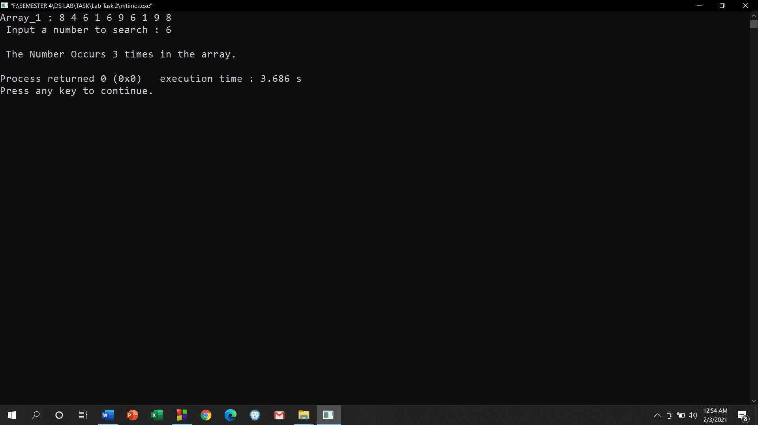

- Initialize an integer array of size 10. Print the number of time each element occurs in the array.
For example,
Array_1 = {8,4,6,1,6,9,6,1,9,8}
Output:
8 occurs = 2 times
4 occurs = 1 time
6 occurs = 3 times
1 occurs = 2 times
9 occurs = 2 times

Your code here:
#include<iostream>
using namespace std;

int main()
{
int arr[100], dup[100];
int size=10, i, j, count;

cout<<"Enter elements in array: ";
for(i=0; i<size; i++)
{
cin>>arr[i];

}

for(i=0; i<size; i++)
{
count = 1;
for(j=i+1; j<size; j++)
{

if(arr[i]==arr[j])
{
count++;

dup[j] = 0;
}
}

if(dup[i] != 0)
{
dup[i] = count;
}
}

for(i=0; i<size; i++)
{
if(dup[i] != 0)
{
cout<<arr[i]<<" Occurs = "<<dup[i]<<" Times"<<endl;

}
}

return 0;
}

Your whole Screenshot here: (Console Output):

